Here are two similar exercise sets sheet 7 lecture 5 with adjusted numbers:

Implementation of DBMS
Exercise Sheet 7 WS 2024 / 2025
1) Suppose that blocks can hold either four records, 15 key-pointer pairs, or 60 pointers.
Questions:
a) We use the indirect bucket scheme. If each search-key value appears in 20 records, how many blocks do we need to hold 6000 records and its secondary index structure? How many blocks would we need if we did not use buckets but a key-pointer pair for each record?
b) We want to retrieve all records for a particular search key. In doing so, we sequentially scan the key-pointer pairs in the index from the beginning until we find the search key value we are looking for. We assume that records with the same search key never share a block. We also assume that buckets never extend across different blocks and that key-pointer pairs with the same key are all in the same block. How many blocks do you have to inspect on average for the two scenarios in a?

2) We would like to sort the tuples of a relation R(X, Y, Z). Initially, the tuples are stored in secondary storage in a random order. At the end, they have to be in secondary storage sorted according to the values of attribute X (search key).
The following information is known about the relation:
- The relation R has 120,000 tuples.
- The size of a block is 8192 bytes. Blocks have a header of 80 bytes.
- The sizes of attributes are 40 bytes for X, 160 bytes for Y, and 120 bytes for Z. Records have a header of 32 bytes.
- Each block holding R tuples is full of as many R tuples as possible. We use unspanned storage for the records and the key-pointer pairs in c.
- A record pointer is 10 bytes.
Questions:
a) If we use the 2PMMS sorting algorithm with two passes, what is the minimum amount of main memory (in number of blocks) required?
b) What is the cost of the two-pass sorting algorithm in terms of the number of I/Os?
c) Consider the following variant of the sorting algorithm. Instead of sorting the entire tuples, we just sort the pairs <key, recordPointer> for each tuple. As in the conventional two-pass sorting algorithm, we sort chunks of <key, recordPointer> in main memory and write the chunks to disk. In the merge phase, <key, recordPointer> entries from different chunks are merged. The record pointers are used to recover the rest of the tuple (from the original copy of R) and write the sorted relation to the disk. What is the cost in terms of the number of I/Os?

Implementation of DBMS
Exercise Sheet 7, WS 2024 / 2025
1) Suppose that blocks can hold either five records, 12 key-pointer pairs, or 40 pointers.
Questions:
a) We use the indirect bucket scheme. If each search-key value appears in 15 records, how many blocks do we need to hold 4500 records and its secondary index structure? How many blocks would we need if we did not use buckets but a key-pointer pair for each record?
b) We want to retrieve all records for a particular search key. In doing so, we sequentially scan the key-pointer pairs in the index from the beginning until we find the search key value we are looking for. We assume that records with the same search key never share a block. We also assume that buckets never extend across different blocks and that key-pointer pairs with the same key are all in the same block. How many blocks do you have to inspect on average for the two scenarios in a?

2) We would like to sort the tuples of a relation R(M, N, O). Initially, the tuples are stored in secondary storage in a random order. At the end, they have to be in secondary storage sorted according to the values of attribute M (search key).
The following information is known about the relation:
- The relation R has 80,000 tuples.
- The size of a block is 4096 bytes. Blocks have a header of 40 bytes.
- The sizes of attributes are 50 bytes for M, 180 bytes for N, and 110 bytes for O. Records have a header of 24 bytes.
- Each block holding R tuples is full of as many R tuples as possible. We use unspanned storage for the records and the key-pointer pairs in c.
- A record pointer is 6 bytes.
Questions:
a) If we use the 2PMMS sorting algorithm with two passes, what is the minimum amount of main memory (in number of blocks) required?
b) What is the cost of the two-pass sorting algorithm in terms of the number of I/Os?
c) Consider the following variant of the sorting algorithm. Instead of sorting the entire tuples, we just sort the pairs <key, recordPointer> for each tuple. As in the conventional two-pass sorting algorithm, we sort chunks of <key, recordPointer> in main memory and write the chunks to disk. In the merge phase, <key, recordPointer> entries from different chunks are merged. The record pointers are used to recover the rest of the tuple (from the original copy of R) and write the sorted relation to the disk. What is the cost in terms of the number of I/Os?

Similar New Exercise
Implementation of DBMS
Exercise Sheet 7
1) Suppose that blocks can hold either five records, 20 key-pointer pairs, or 80 pointers.
Questions:
a) We use the indirect bucket scheme. If each search-key value appears in 25 records, how many blocks do we need to hold 7500 records and its secondary index structure? How many blocks would we need if we did not use buckets but a key-pointer pair for each record?
b) We want to retrieve all records for a particular search key. In doing so, we sequentially scan the key-pointer pairs in the index from the beginning until we find the search key value we are looking for. We assume that records with the same search key never share a block. We also assume that buckets never extend across different blocks and that key-pointer pairs with the same key are all in the same block. How many blocks do you have to inspect on average for the two scenarios in a?
2) We would like to sort the tuples of a relation R(A,B,C). Initially, the tuples are stored in secondary storage in a random order. At the end, they have to be in secondary storage sorted according to the values of attribute A (search key).
The following information is known about the relation:
- The relation R has 150,000 tuples.
- The size of a block is 4,096 bytes. Blocks have a header of 64 bytes.
- The sizes of attributes are 20 bytes for A, 120 bytes for B, and 100 bytes for C. Records have a header of 16 bytes.
- Each block holding R tuples is full of as many R tuples as possible. We use unspanned storage for the records and the key-pointer pairs in c.
- A record pointer is 8 bytes.
Questions:
a) If we use the 2PMMS sorting algorithm with two passes, what is the minimum amount of main memory (in number of blocks) required?
b) What is the cost of the two-pass sorting algorithm in terms of the number of I/Os?
c) Consider the following variant of the sorting algorithm. Instead of sorting the entire tuples, we just sort the pairs <key,recordPointer> for each tuple. As in the conventional two-pass sorting algorithm, we sort chunks of <key,recordPointer> in main memory and write the chunks to disk. In the merge phase, <key,recordPointer> entries from different chunks are merged. The record pointers are used to recover the rest of the tuple (from the original copy of RRR) and write the sorted relation to the disk. What is the cost in terms of the number of I/Os?

Question 1a:
- Suppose that blocks can hold either 4 records, 12 key-pointer pairs, or 60 pointers.
a) We use the indirect bucket scheme. If each search-key value appears in 15 records, how many blocks do we need to hold 4500 records and its secondary index structure? How many blocks would we need if we did not use buckets but a key-pointer pair for each record?
b) We want to retrieve all records for a particular search key. In doing so, we sequentially scan the key-pointer pairs in the index from the beginning until we find the search key value we are looking for. We assume that records with the same search key never share a block. We also assume that buckets never extend across different blocks and that key-pointer pairs with the same key are all in the same block. How many blocks do you have to inspect on average, for the two scenarios in a)?

Question 1b:
- Suppose that blocks can hold either 5 records, 15 key-pointer pairs, or 75 pointers.
a) We use the indirect bucket scheme. If each search-key value appears in 20 records, how many blocks do we need to hold 6000 records and its secondary index structure? How many blocks would we need if we did not use buckets but a key-pointer pair for each record?
b) We want to retrieve all records for a particular search key. In doing so, we sequentially scan the key-pointer pairs in the index from the beginning until we find the search key value we are looking for. We assume that records with the same search key never share a block. We also assume that buckets never extend across different blocks and that key-pointer pairs with the same key are all in the same block. How many blocks do you have to inspect on average, for the two scenarios in a)?

Question 1c:
- Suppose that blocks can hold either 6 records, 18 key-pointer pairs, or 90 pointers.
a) We use the indirect bucket scheme. If each search-key value appears in 25 records, how many blocks do we need to hold 7500 records and its secondary index structure? How many blocks would we need if we did not use buckets but a key-pointer pair for each record?
b) We want to retrieve all records for a particular search key. In doing so, we sequentially scan the key-pointer pairs in the index from the beginning until we find the search key value we are looking for. We assume that records with the same search key never share a block. We also assume that buckets never extend across different blocks and that key-pointer pairs with the same key are all in the same block. How many blocks do you have to inspect on average, for the two scenarios in a)?

Question 2:
c) Consider the following variant of the sorting algorithm. Instead of sorting the entire tuples, we just sort the pairs for each tuple. As in the conventional two pass sorting algorithm, we sort chunks of in main memory and write the chunks to disk. In the merge phase, entries from different chunks are merged. The record pointers are used to recover the rest of the tuple (from the original copy of R) and write the sorted relation to the disk. What is the cost in terms of number of I/Os?

Detailed and Precise Explanation of the Solution
We need to sort the tuples of relation R(A,B,C) using the Two-Pass Multiway Merge Sort (2PMMS) algorithm. Given the problem constraints, we will analyze each part of the question step by step.

Step 1: Understanding the Given Data
- Relation Size and Tuple Structure:
  - Each tuple consists of attributes A,B,CA, B, CA,B,C and a record header.
  - Sizes:
    - A=32 bytes
    - B=200 bytes
    - C=140 bytes
    - Record header = 28 bytes
  - Total tuple size = 28+32+200+140=400 bytes
- Block Size and Storage Constraints:
  - Block size = 4096 bytes
  - Block header = 60 bytes
  - Available space per block = 4096−60=4036 bytes
  - Since we use unspanned storage, each block can only store complete tuples.
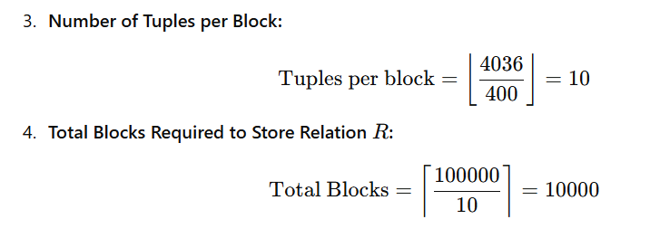

Part (a): Minimum Memory Blocks for 2PMMS
The Two-Pass Multiway Merge Sort (2PMMS) sorts a relation in two passes:
- Pass 1: Sorting Initial Runs
  - With nnn memory blocks, we can sort nnn blocks at a time.
  - This produces ⌈10000/n⌉ sorted runs.
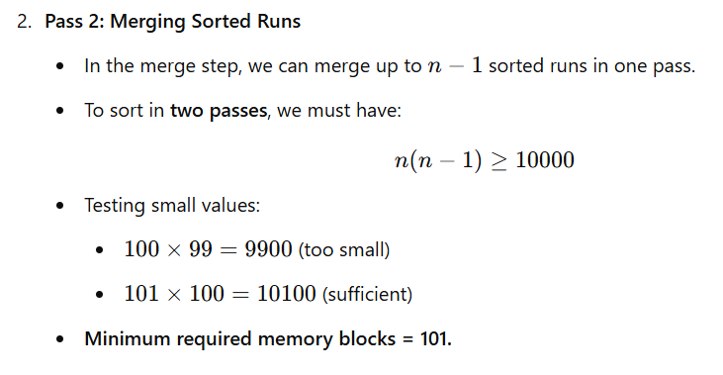

Part (b): Cost of 2PMMS in Terms of I/Os
The I/O cost includes:
- Pass 1: Reading and Sorting the Blocks
  - Read all 10000 blocks: 10000 I/Os
  - Write back sorted runs: 10000 I/Os
- Pass 2: Merging Sorted Runs and Writing Final Output
  - Read all 10000 blocks: 10000 I/Os
  - Write back the final sorted relation: 10000 I/Os
Total I/Os =10000+10000+10000+10000=40000

Part (c): Sorting Key-Pointer Pairs Instead of Full Tuples
Instead of sorting the full tuples, we sort (key, record pointer) pairs and use the record pointers to retrieve full tuples later.
- Key-Pointer Pair Size:
  - Key A=32 bytes
  - Record pointer = 8 bytes
  - Total size = 32+8=40 bytes

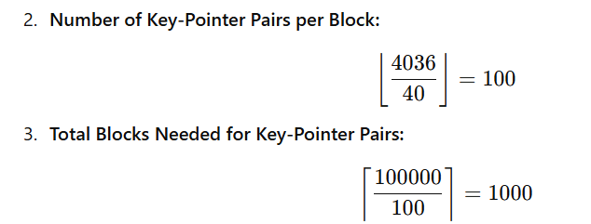
- Sorting Costs in Terms of I/Os:
  - Step 1: Read relation R and construct key-pointer pairs → 10000 I/Os
  - Step 2: Write the key-pointer sorted sublists to disk → 1000 I/Os
  - Step 3: Read the sorted sublists back from disk → 1000 I/Os
  - Step 4: Retrieve full tuples using pointers (one I/O per tuple) → 100000 I/Os
  - Step 5: Write the final sorted relation back to disk → 10000 I/Os
Total I/Os=10000+1000+1000+100000+10000=122000

Summary of Results
Part | Description | Total I/Os
(a) | Minimum memory blocks required for 2PMMS | 101
(b) | Standard 2PMMS sorting I/O cost | 40000
(c) | Sorting key-pointer pairs instead of full tuples | 122000
Sorting just key-pointer pairs increases I/O cost significantly because retrieving full tuples after sorting adds 100000 I/Os.

Key Takeaways
- Sorting the full relation using 2PMMS is more efficient (40000 I/Os).
- Sorting key-pointer pairs may save memory but incurs extra retrieval costs, making it much more expensive (122000 I/Os).
- More main memory blocks (higher n) reduce the number of sorted runs and lower I/O costs.

Key Features of These Questions:
- Block Structure:
  - Each block can hold a fixed number of records, key-pointer pairs, or pointers.
- Indexing Schemes:
  - The indirect bucket scheme is used in one scenario, while a direct key-pointer scheme is used in the other.
- Data Distribution:
  - Each search-key value appears in a fixed number of records (e.g., 10, 15, 20, 25).
- Retrieval Process:
  - The questions involve calculating the number of blocks to inspect on average when retrieving all records for a given search key.

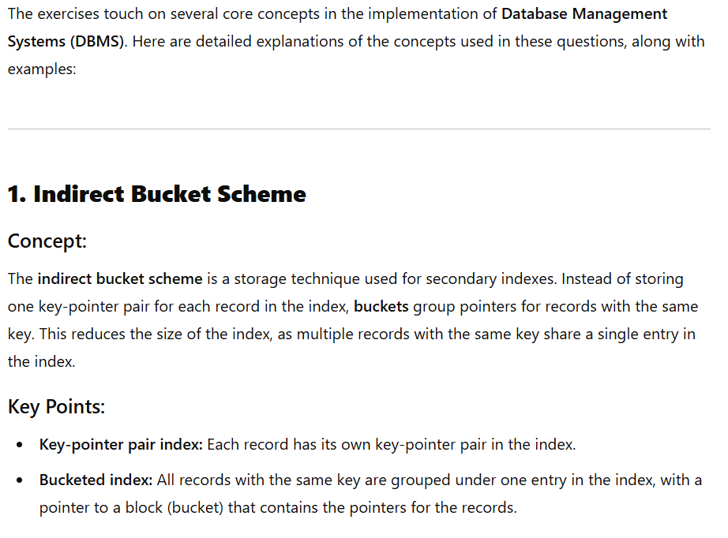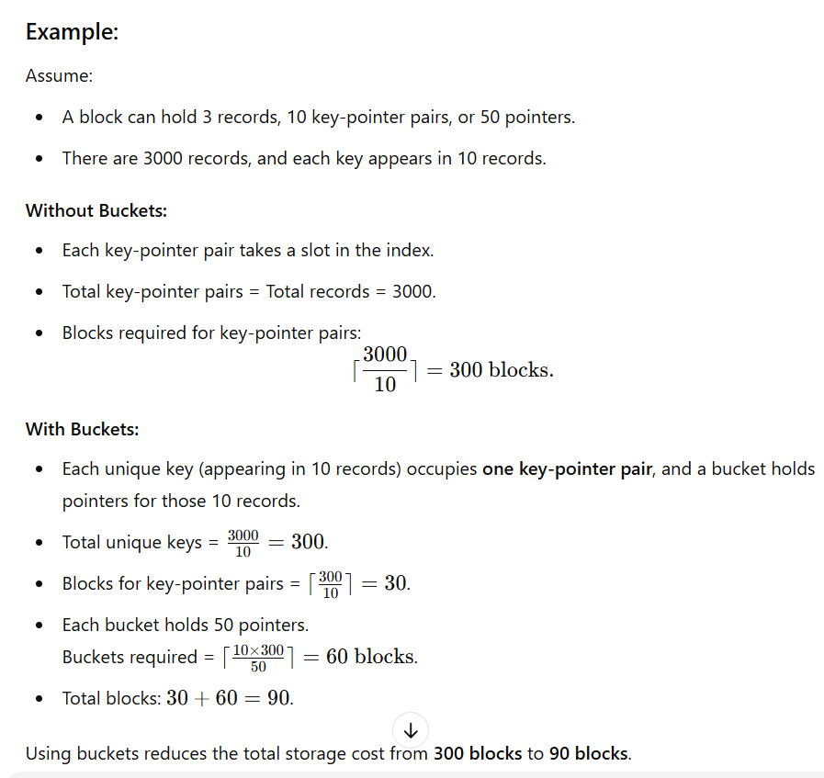

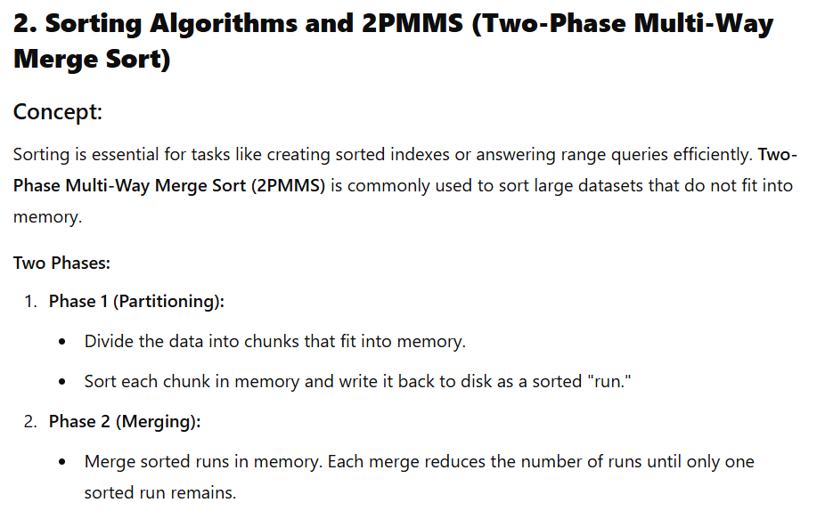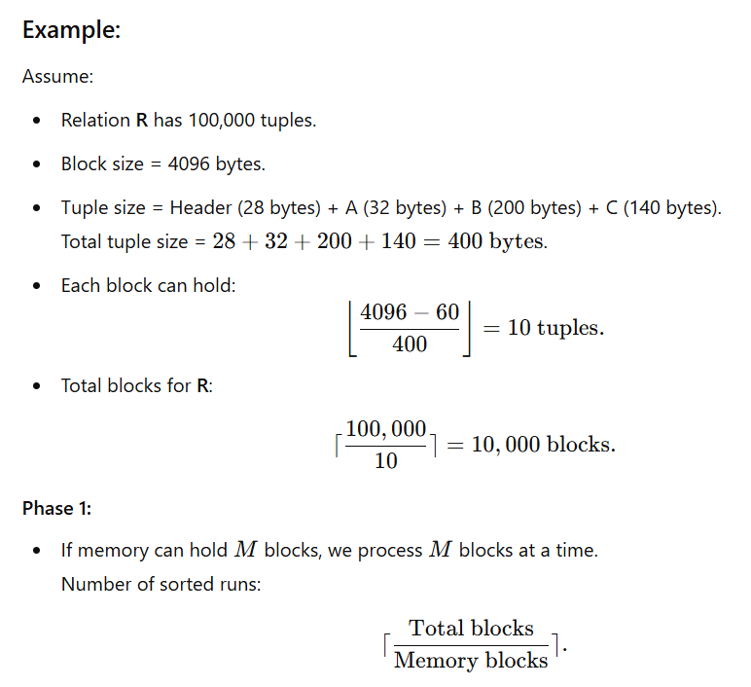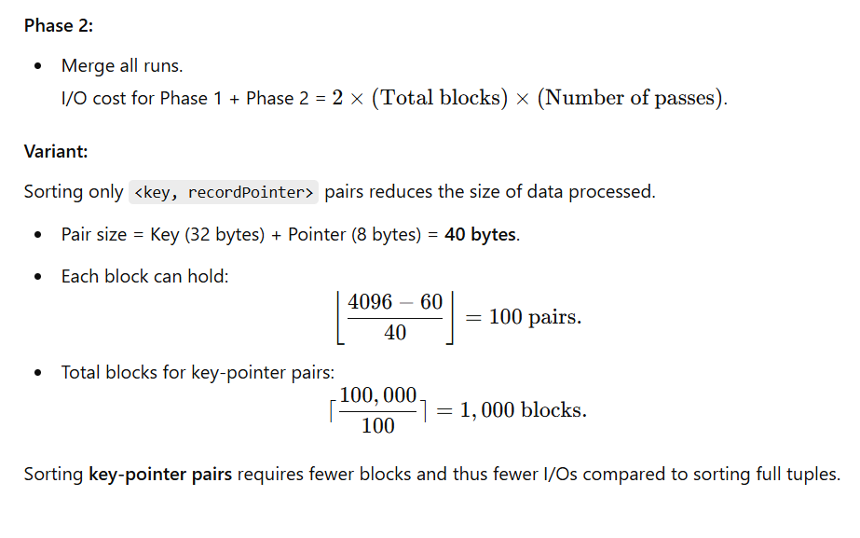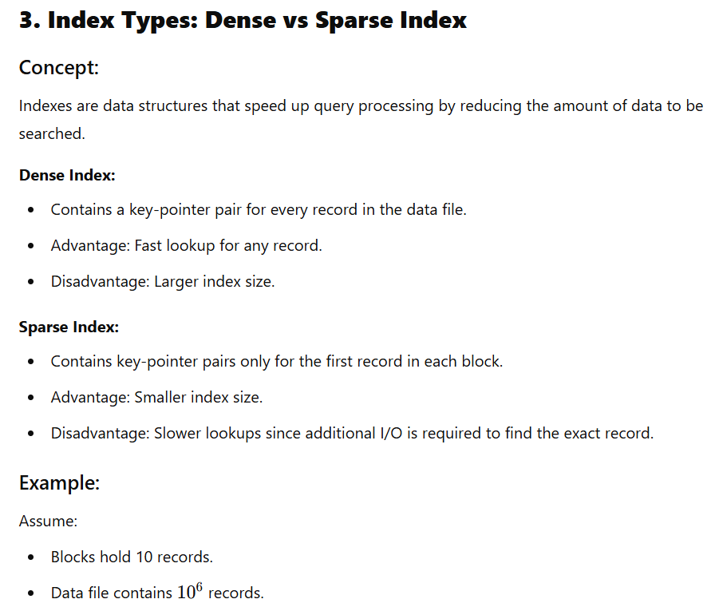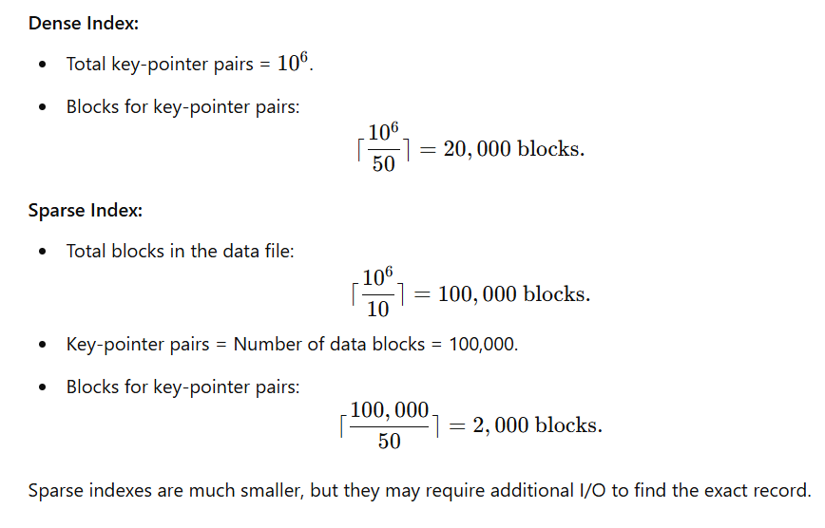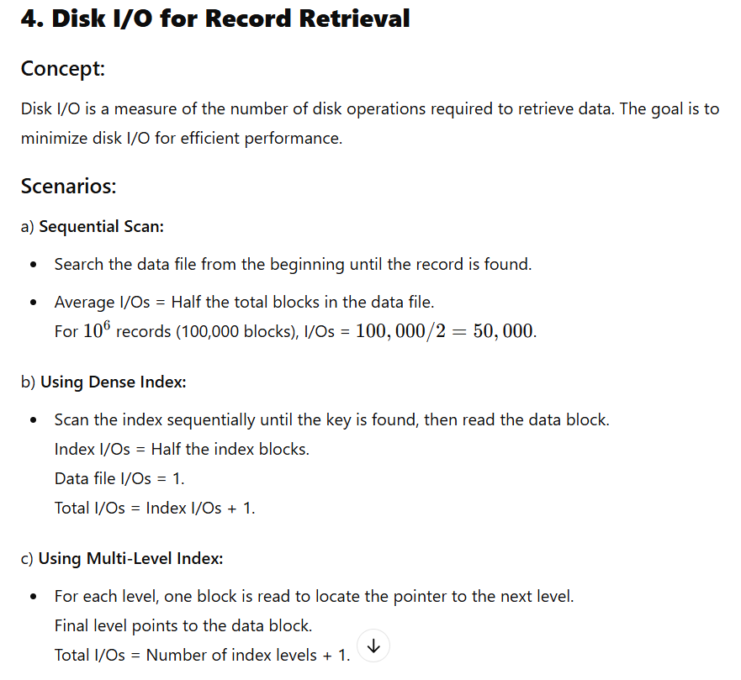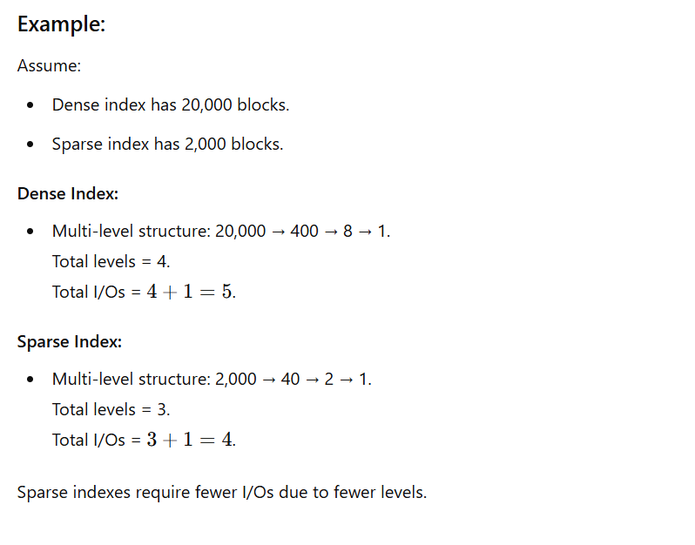

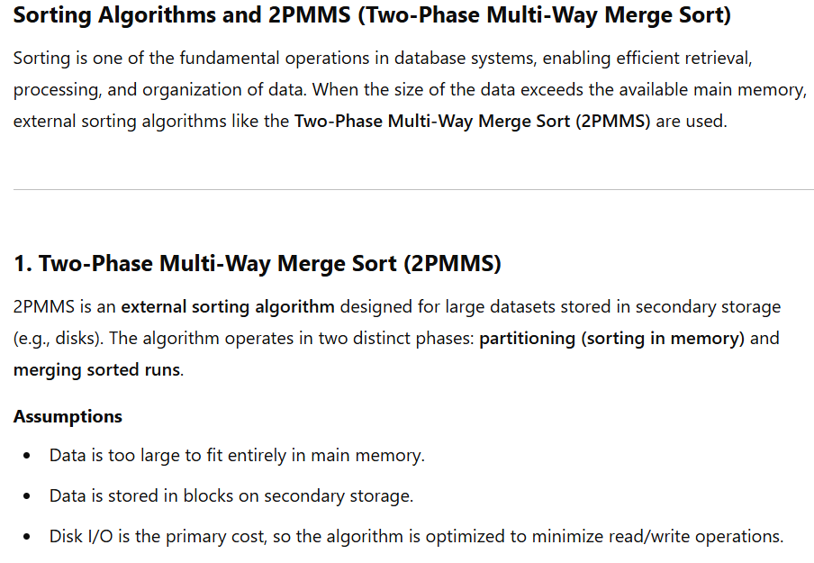
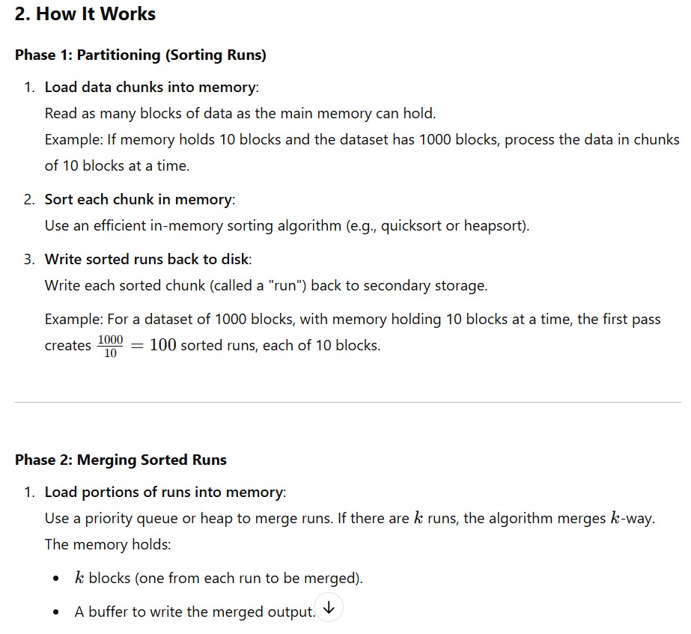
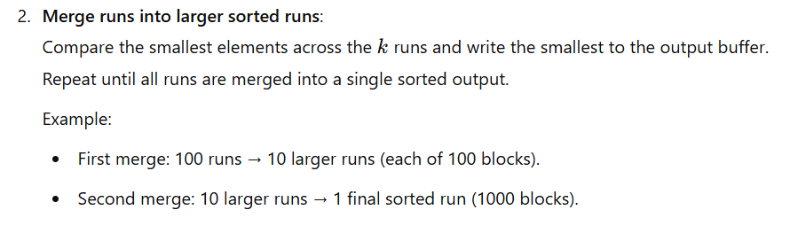
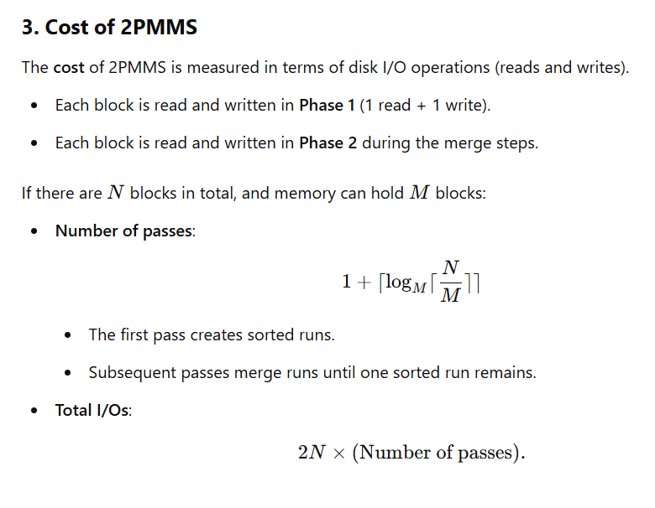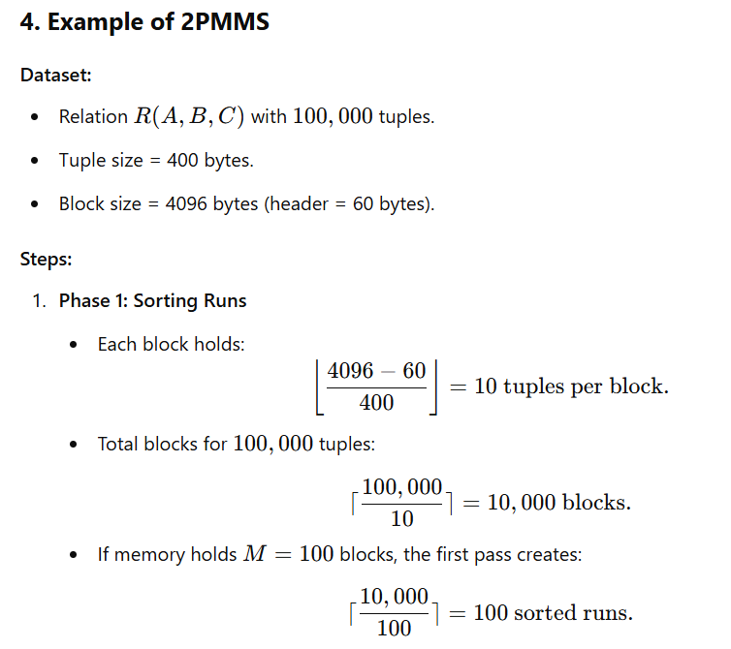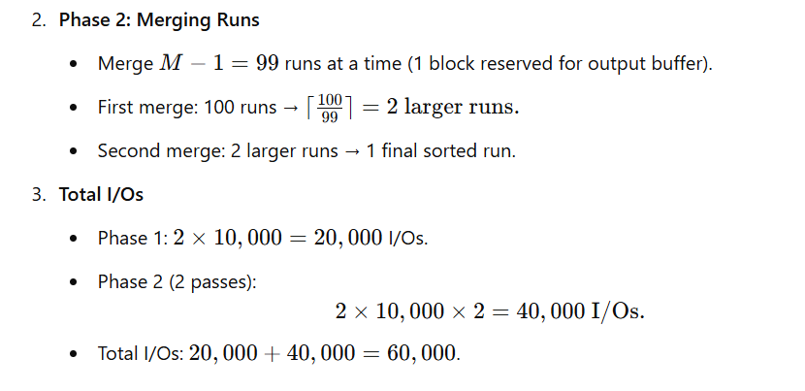
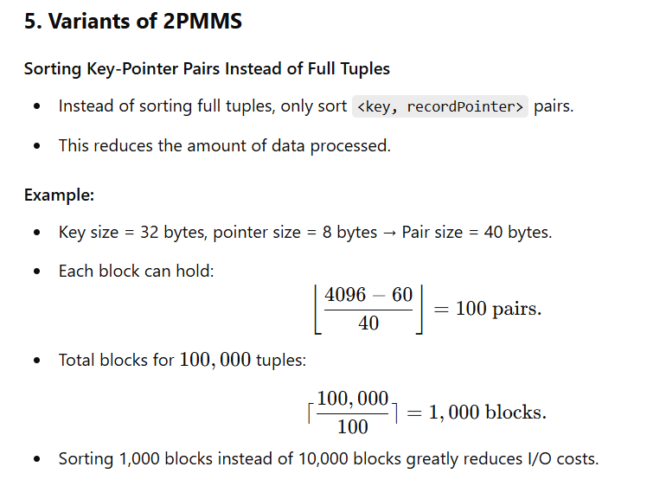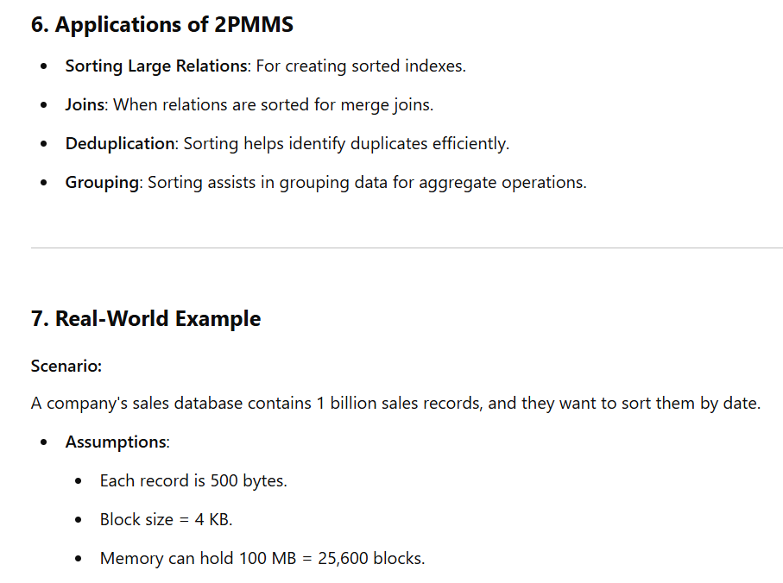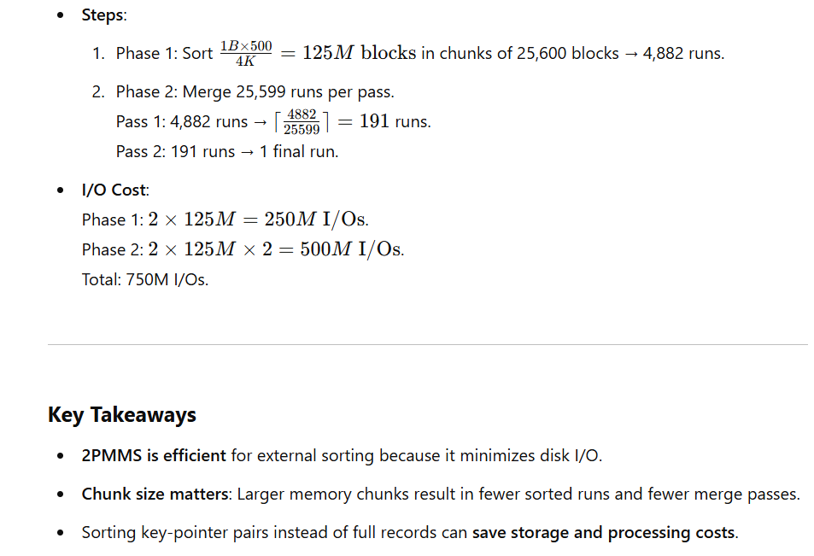

Solutions to Exercise Sheet 7
